Circuits
Laboratory Exercise No: 4
Multisim Simulation
Introduction to Multisim
There are several computer software packages which can be used for circuit analysis. The most popular is Spice, which stands for Simulation Program with Integrated-Circuit Emphasis. Spice was developed at the Department of Electrical and Computer Engineering at the University of California at Berkeley in the 1970s for mainframe computers. Since then, more than 20 versions have been developed. Among these versions, Multisim, LTspice and Tina are the most popular software in many universities in China. You can choose your own preference in deciding which one you would like to use. Multisim might be powerful and good for the beginners, however, LTspice is free for use. In this lab exercise, we take Multisim as a model example. After understanding this software, you can easily learn to use other ones. Multisim is the schematic capture and simulation application of Circuit Design Suite, a suite of EDA (Electronics Design Automation) tools that helps you carry out the major steps in the circuit design flow. For a circuit to be analyzed by Multisim, you must take three steps: (1) create the circuit, (2) simulate it, and (3) print or plot the results.
We have installed the licensed Multisim on the computers in our lab. If you want to install one on your laptop, you can download Multisim 14.0 student version.
- Pre-Lab Work
Read the following instructions from I to IV and learn how to use Multisim.
I. Multisim User Interface
The Multisim user interface includes the following elements:
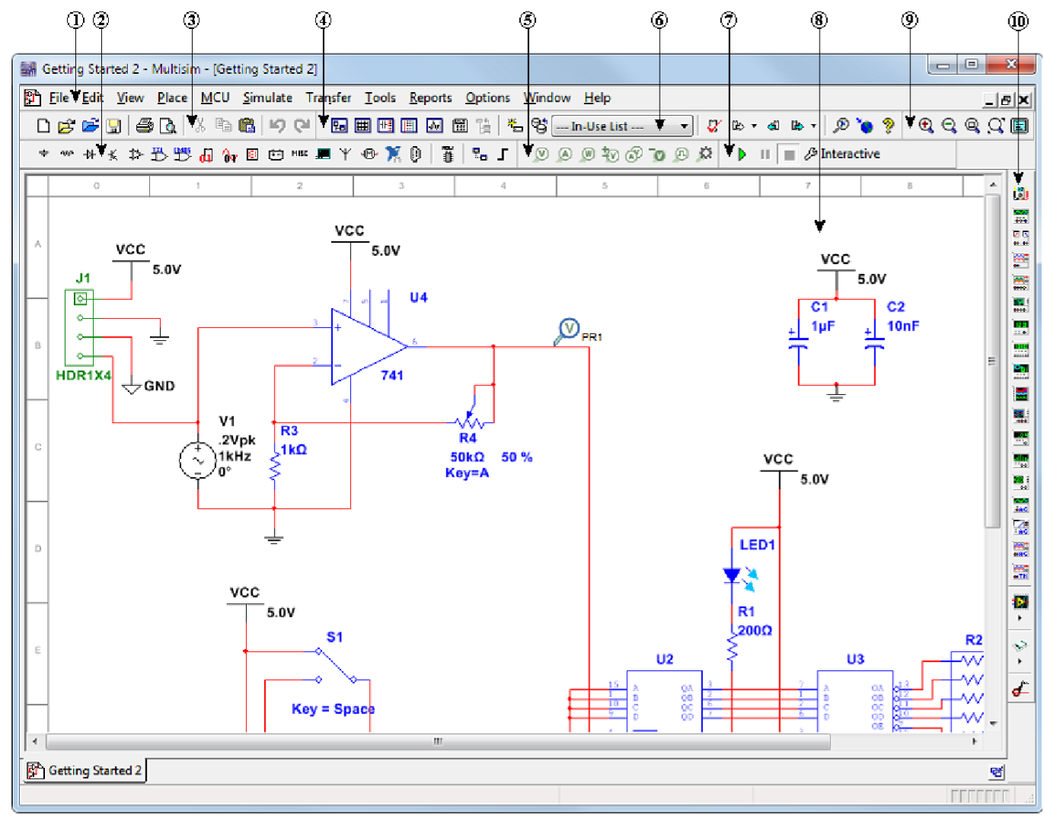
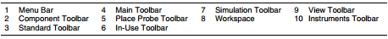
Figure 1. Multisim User Interface
Refer to the table below as needed:
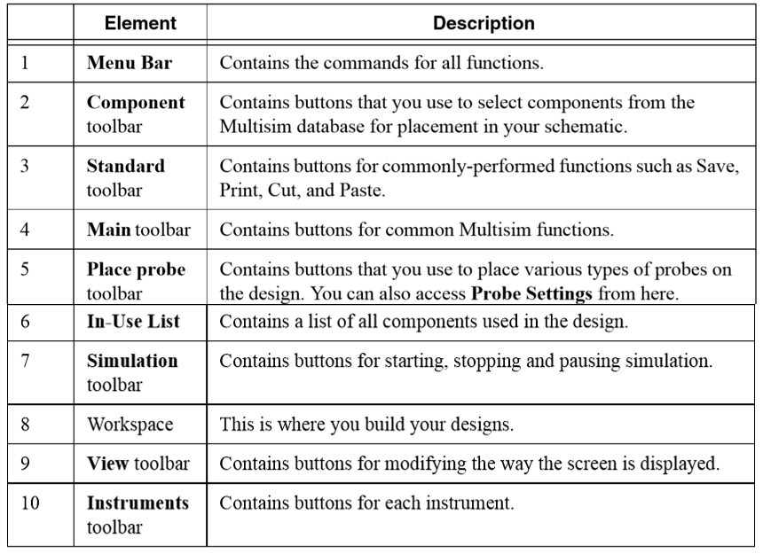
II. Creating a Circuit (Schematic Capture)
In this section, you will learn how to create the circuit shown in Figure 2 using the Schematics program.
Figure 2. Circuit 1
Tip: You can access the online help at any time by pressing F1 on your keyboard, or by clicking the Help button in a dialog box.
Step 1: Placing the Components
a). Select Place » Component or click component toolbar to display the Select a Component dialog box.
b). Select the Basic component Group and the RESISTOR component Family.
c). Select 1K from the Component list and click OK.
d). Move the cursor to the workspace and click to place the component.
e). Click OK again to place another resistor until you get enough resistors.
f). Similarly, in Select a Component dialog box, the sources component Group and the POWER_SORCES component Family, select and place DC POWER and GROUND respectively.
g). In Select a Component dialog box, the analog component Group and the OPAMP component Family, select and place LM324.
h). In Select a Component dialog box, the indicators component Group and the VOLTMETER component Family, select and place VOLTMETER_H.
i). From the Instruments toolbar (see Fig.1 toolbar10), select and place Oscilloscope.
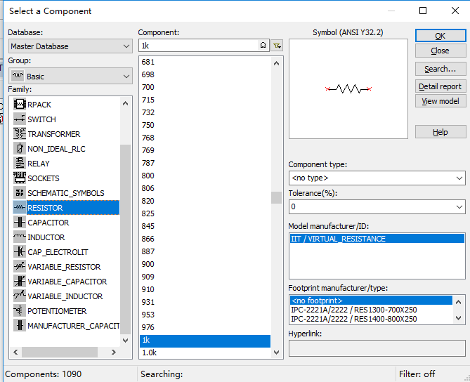
Figure 3. Select a Component dialog box
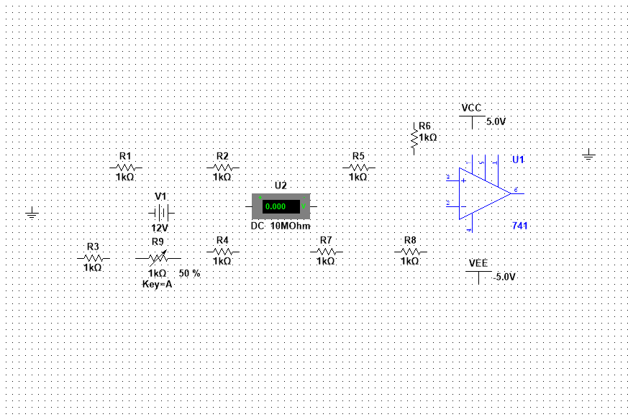
Figure 4. Placing Components
Tip: How to change a component into a verticle direction
While placing resistor R6, press <Ctrl-R> to rotate it to a vertical orientation.
After placing resistors, double-click on each and change the Resistance to value you need, like 390 Ω, 47 kΩ and 220 kΩ.
Tip: The Group and Family location of each component is listed in the Component Locations section.
Tip: How to change Reference Designators
Reference Designators (for example, R1, R2) are assigned in the order the components are placed. If you place components in a different order with those in the original design, the numbering will differ. If you want to change it, double-click it and change the label.
Step 2: Wiring the Design
All components have pins. Each pin can connect three other wires in different directions. When your cursor is moved over a pin, the cursor changes to a crosshair, indicating you can start wiring.
Complete the following steps to wire the design:
1. Click a pin on a component (your cursor turns into a crosshair) and move the mouse. A wire appears, attached to your cursor.
2. Click a pin on the second component. Multisim automatically places the wire, which snaps to an appropriate configuration.
Tip: You can also control the flow of the wire by clicking somewhere as you move the mouse. Each click “fixes” the wire to that point.
Tip: How to show the numbers at nodes.
Select Options » Sheet properties (or right-click in workspace, or <Ctrl+M>, select Properties) » Sheet visibility » Net names » Show all, Reference Designators will be all shown on the circuit.
III. DC Analysis
DC analysis is one of the standard analyses that Multisim can perform. Other standard analyses include transient, AC, and Fourier. Under DC analysis, there are two kinds of simulation that Spice can execute: DC nodal analysis and DC sweep.
a). Virtual Instrumentation
Multisim provides virtual instruments to monitor and display the results of the analysis. Wiring proper virtual instruments to the circuit, the calculating results can be displayed on the instruments, very similar to practical experiments or tests. For example, Voltmeter 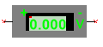 can be used to measure the branch voltage, Volt Probe  can be used to measure the node voltage, and the Oscilloscope can be used to measure the node voltage and show its waveform.
To run circuit 1, double-click the oscilloscope icon to show its front panel. Select Simulate » Run or click toolbar7 shown in Fig.1 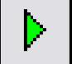. The output of the op-amp appears on the virtual instrument.
b). DC Nodal Analysis (DC Operating Point)
Spice allows DC nodal analysis to be performed on sources with an attribute of the form DC=value and provides the DC voltage at each node of the circuit and DC branch currents if required. To view DC node voltages and branch currents requires,
- select Simulate » Analyses and simulation,
- in Active Analysis: select DC Operating Point,
- in Variables in circuit: select the variables you want to know and add them to Selected variables for analysis,
Tip: How to show the current on a short-circuit line
Under DC Operating Point analysis, variables which can be output from a circuit include currents on each voltage source (entering ‘+’ polarity of a voltage source), voltages at each node and absorbing powers by each component. To show a current on a short-circuit line, you can
a) place a voltage source with zero volt on the line, set the ‘+’ sign on the side in which the current enters and output I(V).
b) select Current Probe from toolbar5 in Fig.1 and place it on the short-circuit line. After running the circuit, the current will be shown on the circuit.
IV. Output Export
The variables in a circuit calculated by Multisim can be displayed in Grapher View in form of curve or data table, and be saved as original data for Multisim PostProcessor or can be exported to other software（for example, Microsoft Excel）to do further calculation or to draw graph.
1). The Grapher
The Grapher is a multi-purpose display tool where you can view, adjust, save and export graphs and charts. It displays:
• the results of all Multisim analyses in analog graphs, digital graphs, or tables.
• a graph of traces for some instruments (for example the results of the Postprocessor, Oscilloscope and Bode Plotter).
Complete the following steps to view results of a simulation on the Grapher:
a). Confirm that Interactive is selected in the Simulation toolbar and run the simulation with the oscilloscope as described earlier.
b). Select View » Grapher if the Grapher is not displayed.
2). The Postprocessor
Use the Postprocessor to manipulate the output from analyses and plot the results on a graph or chart. Types of mathematical operations that can be performed on analysis results include arithmetic, trigonometric, exponential, logarithmic, complex, vector and logic.
3). Reports
You can generate a number of reports in Multisim: Bill of Materials (BOM), Component Detail Report, Netlist Report, Schematic Statistics, Spare Gates and the Cross Reference Report.
The following section uses the BOM as an example for the tutorial design.
Bill of Materials
A bill of materials lists the components used in a design, providing a summary of the components needed to manufacture the circuit board. Information provided for each component includes:
• quantity required.
• description, including the type of component (for example, resistor) and value (for example, 390 Ω).
• reference designator.
• package or footprint name.
Select Reports » Bill of Materials to display a report.
2. Lab Section
In this laboratory, you will learn how to use Multisim to analyze/simulate DC circuits including creating circuits, DC Operating Point, DC Sweep and exporting results. The exercises include two parts.
Part 1 DC Operating Point
In this section you will learn how to use DC Operating Point to simulate the Instrumentation of Wheatstone Bridge and Differential Amplifier which you have done in Lab 3
(i) Build the circuit shown in Fig.1. Use a variable resistor to replace ΔR, double-click it, set the Value of Resistance, Key to control it and the Increment to fit for ΔR given in Table 2 below.
(ii) Run the circuit to finish the virtual measurement and fill in the form shown in Table 2.
Table 2. Data Table for Wheatstone Bridge and Differential Amplifier Instrumentation
Measurement | V_{out from Bridge} (mV) | V_{out from op-amp} (mV) | ΔR  (Ω) | ΔR/R | G_{Measured} | G_{Theoreticle} | Error %
1 |  |  | 10
2 |  |  | 5
3 |  |  | 2
4 |  |  | 0
5 |  |  | -1
6 |  |  | -3
7 |  |  | -7
(iii) Save and export your schematic circuit, graph view of any outputs and Bill of Materials.
(iv) Discussion: Do the results agree with the theory? Give some possible reasons. Change the Op-amp LM324 to OP37 and repeat the measurement and refill Table 2. What conclusion can you come to?
Part 2 DC Operating Point
In this section you will learn how to use DC Operating Point to prove Reciprocal Theorem which states: in linear circuit which only includes one independent source and no dependent sources, the locations of voltage source and any branch current can be exchanged and the value of current will keep the same.
- (b)
Figure 5. circuit 2. Exchange of voltage source and current I
(i) Build the circuit shown in Fig.5. Place two voltage sources on both goal branches and set one to 12V and the other 0V.
(ii) Select Place current probe (see toolbar5 ) on the branches 12V and I .
(iii) Run the circuit and export the results.
Discussion: What conclusion can you get from (iii)?
Part 3 DC Sweep
In this section you will learn how to use DC Sweep to find the Thevenin equivalence for the circuit shown in Fig.6(a). The result is shown in Fig.6(b).

Figure 6. Circuit 3 and the equivalence
(i) Build the circuit shown in Fig.6(a). Supply a current source at the terminals and set node 4 as output.
(ii) Select Simulate » Analyses and simulation, in Active Analysis: select DC Sweep,
(iii) In Analysis Parameters, select Source2 A1 as the parameter to be sweeped, set the Start value to -2A, the Stop value to 2A, the Increment to 0.2A. Then select Output and add V4 to Analog graph.
(iv) Run the circuit and show the graph of I-V.
(v) Analize the I-V curve and find V_{oc} and R₀.
(vi) Discussion: How to use DC Operating Point to find V_{oc} and R₀? Show your method and the results.

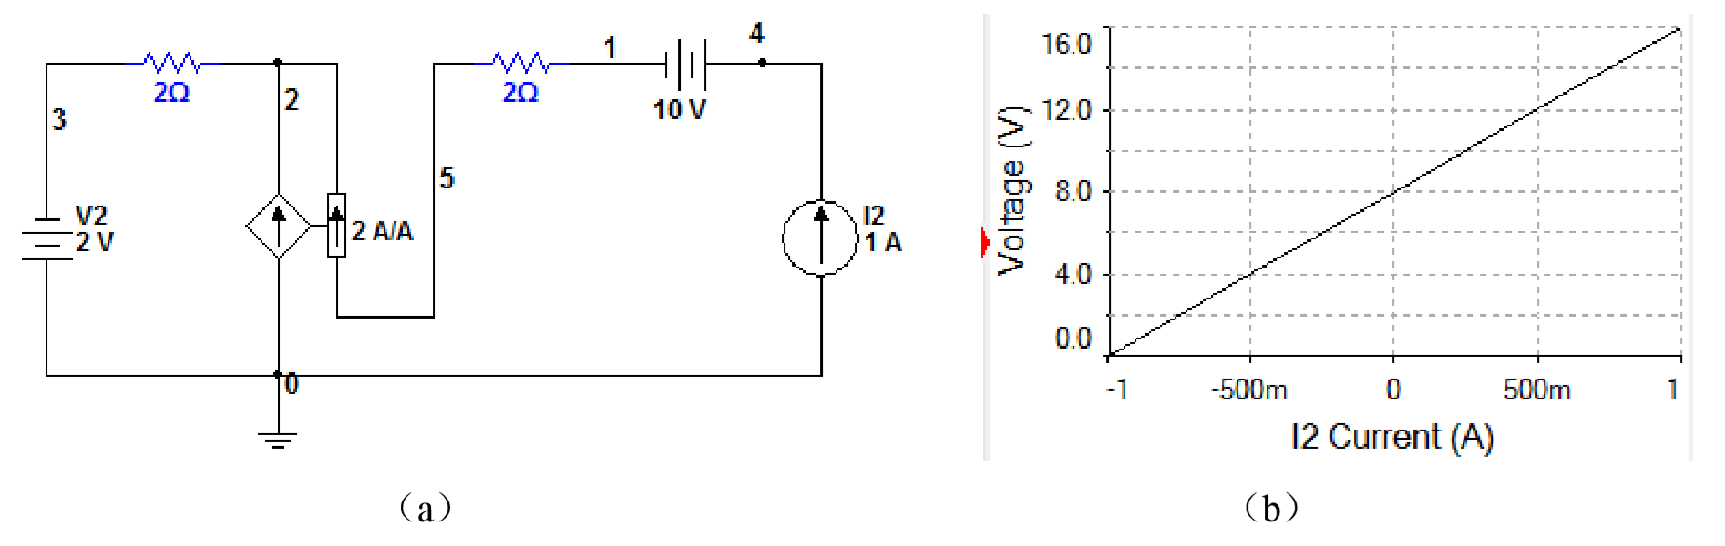
Figure7. Circuit 3 built in Multisim
- Lab Report Submission
The report is supposed to be submitted individually and it should include:
- Circuits built in Multisim from Part 1 to Part 3,
- Output graph view export,
c) Calculations and discussion questions,
d) Data tables,

